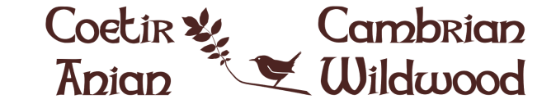

PRESS RELEASE
19.10.15

Appeal to save part of Cambrian Mountains for wildlife

An appeal is on to save an area of the Cambrian Mountains near Aberystwyth from becoming a conifer plantation. A local and visionary charity is hoping instead to establish a project on the land to reverse the environmental damage in this part of Wales and create a haven for wildlife, by restoring the native wildwood and other natural habitats.

Cambrian Wildwood, or Coetir Anian, proposes an area of 3,000 acres in the beautiful Dyfi Biosphere for the project. The land identified is unfarmed moorland and existing conifer plantations. The project is raising money for its first 350 acres, an area of moorland currently on the market which is at risk from becoming another conifer plantation. The vision of Wales Wild Land Foundation, the charity promoting the project, is to create a haven for wildlife and for the benefit of local people and visitors.

If successful, the charity will plant native woodland, and restore heathland. The restored habitats will attract wildlife, and there are plans to re-establish some species to the area. Next year, pine marten will be released on the neighbouring Welsh Government land to bolster the small remnant population. And longer term plans may see the reintroduction of red squirrel and water vole. The land will be grazed by wild ponies, as a natural part of the ecology.

An open access policy will welcome people to enjoy the Wildwood, including wild camping and organised activities and events in nature.

In order to save the land, the charity needs the public’s help to raise £360,000. If you would like to help with this pioneering project, donations of any amount can be made via the website at www.cambrianwildwood.org or www.coetiranian.org. Pledges can be made by sending a message from the website.

END

PHOTOS ATTACHED
(Higher resolution images are available)

Moorland and spruce 09.05.15
“Moorland and neighbouring conifer plantation which will hopefully form the initial area for Cambrian Wildwood”

Tree planting Cambrian Wildwood
“Volunteers planting trees near the Cambrian Wildwood site”

Wildwood scene 19.10.13
“An existing area of wildwood near the Cambrian Wildwood site”

Red Squirrel
“Red squirrel will be returned to the wildwood area when conditions are suitable”

NOTES

Wales Wild Land Foundation CIO is a Charity Registered in England and Wales Nº 1158185
President: Sue Jones-Davies
Patron: George Monbiot

Cambrian Wildwood is the charity’s main project.

More information is available on www.cambrianwildwood.org and www.coetiranian.org

Contact: admin@cambrianwildwood.org

